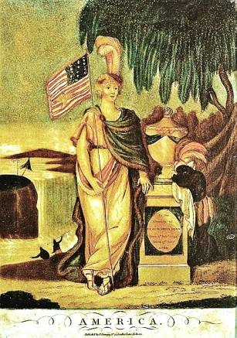
Name_________________________________ period_____
Unit 4: The Early Republic Prezi Notes
Why was whiskey essential to farmers in the late 18th Century?  Do you believe that political parties are beneficial or destructive to America today? Explain.  Did Adams have the right to censure criticism of US Government?  Can there be justification to limit free speech in America?  Jefferson believed in limited government and financial responsibility, but still purchased Louisiana. What do you think motivated him to go against his principles in this instance?  Even though no territory was lost or gained, American pride swelled after the War of 1812. Explain why.  The US would not be able to enforce this without the help of Britain. Why did the English agree to help? | George Washington’s Presidency (_________-________)  The national debt had reached ____________________ dollars.  What three things did Hamilton plan to do about it?  1.____________________ the debt  2.raise________________  3.establish a ______________ __________  In western PA, farmers revolted after taxes were raised on Whiskey (essential to their livelihood). This was called the _________________ ________________, and forced Washington to send 13,000 troops to stop it as a show of might.  The Growth of Political Parties: Parties formed to support certain political motives.  Federalists Democratic-Republicans  - Strong National Gov - Fear of _________ rule - Loose interpretation of Constitution - ____________ National bank - Industrial Economy favored by: lawyers, merchants, manufacturers, clergy - ______________ National Gov - Fear of powerful few - ________ interpretation of Constitution - Opposed National bank - _______________ Economy favored by: farmers, tradesmen  What two things did Washington warn Americans about during his farewell address? _______________________ and __________________________
John Adams’ Presidency (__________-__________)
________________________ was elected Vice-President because he had the 2nd highest # of electoral votes despite belonging to the opposing political party.

The incident where three US diplomats were refused an audience with France unless they paid a bribe was called the ______________________________. It angered many Americans and stirred up hostility with France.

The ___________ and ______________ Acts were laws that Adams signed that delayed immigration, made it easier to deport immigrants, and forbade harmful criticism of the government. Many felt these laws were a violation of the 1st Amendment.

Even though he skillfully avoided war with France, Adams lost unpopularity after the aforementioned acts and was defeated in re-election by Jefferson.

Thomas Jefferson’s Presidency (__________-_________)
Jefferson believed in ___________, efficient Government and undid many ________________ Party laws from Adams’ term.

______________ vs. _______________ was a Supreme Court case that determined the principle of judicial review- the precedent that the Supreme Court can declare laws unconstitutional and throw them out. This upset Jefferson and other Dem-Reps who saw it as a power-grab.

In the year _________, Jefferson managed to purchase the __________________ Territory from France for $15 million (3 cents/acre). It doubled the size of America and helped fuel further westward expansion.

In issues of foreign policy, Jefferson believed in strict neutrality with other nations. After conflicts with both England and France, he issued a trade _______________ in 1807. This law damaged the US economy and made many Americans upset at Jefferson.

James Madison’s Presidency (________-_________)
Madison had very similar foreign policy views as Jefferson, but could not avoid war with Britain.

Causes of the War of 1812

Effects of the War of 1812:

After the War, Madison helped establish a Second US National Bank to simplify interstate commerce.

James Monroe’s Presidency (_________-_________)
By the time Monroe (a Dem-Rep) was elected, the Federalist Party dwindled out of favor and would no longer compete for national office.

He secured a clear border with _____________________ in 1818, and was able to secure
_________________ from Spain in 1819.

Seeing itself as the empire (and protector) of the Western Hemisphere, America issued the ______________ ______________, which declared that all of the Americas were off limits to future European colonization or interference. This is unofficially still in place today.

