Unit 8: Sectionalism: A Growing Divide Prezi Notes
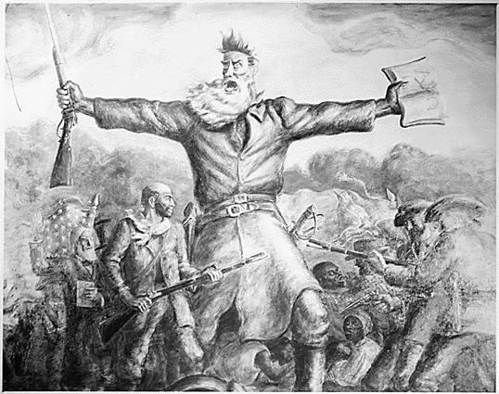
Sectionalism
Sectionalism occurs when specific regions of a country begin to identify with and care about their region instead of the nation as a whole.
For example, the Northern US cared more about themselves and their interests than they did for the interests of the other US regions (South, West). This leads to divisiveness as conflicting interests begin to emerge.
Us “Sections”:
The _____________ was characterized by larger populations, cities, and factories. They favored a centralized bank that would strengthen their region’s economy, and ____________ that would force other Americans to buy northern goods.
The north was also largely against ________________ and many abolitionists became combative towards southern slave owners.

The ________________ is very sparsely populated areas of people that want to remain mostly autonomous from rules and regulations. They will be stuck in the middle of the North vs South political fight in regards to slavery and states’ rights.
The ________________ was sparsely populated and relied strongly on the plantation system. __________ was crucial to the southern economy. They also despised tariffs because they received most of their _____________________ goods from other countries. They begin to feel threatened by northern interests (abolition, central banks, and tariffs).

Slavery Spreads
Conditions on ____________ ___________ were unimaginable, so eventually the transatlantic import of new slaves was banned in ______________. (Smuggling still was commonplace, however.)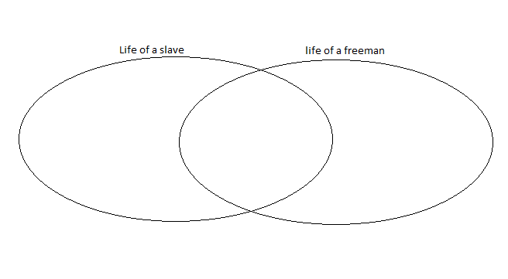
When the _____________ __________ was invented slavery dramatically increased in the South to meet the demand for cotton. The institution of slavery was galvanized and would not go away as many abolitionists had wished.
In the north, abolitionists strategized how to end the horrific practice.
Abolitionists
Abolitionism was widespread throughout the civilized world. Britain banned the practice in 1833. Many Americans wished to do the same, but _________________ would have nothing of it.
The Amistad Case- after ______________ ____________ ____________ retired from politics, he agreed to serve as a lawyer for a group of slaves that overthrew their slave ship. The case went to the Supreme Court and won the enslaved Africans’ freedom. Adams had been a critic of slavery—arguing against Texas annexation.
_______________ __________________ was the “conductor” of the underground railroad- a series of safe-houses and secret routes that helped at least 300 slaves escape to freedom in the north.
_________________ ______________ was an escaped slave that became a famous writer and orator for abolition (who we discussed in unit 7).
_________________ _________ _______________ published “The Liberator” an abolitionist newspaper that received wide publication and fanned the flames of the movement. The publication caused such anger that his home was burned and his press was destroyed.
________________ ________________ _______________ wrote a best-selling, world-famous novel Uncle Tom’s Cabin about slavery in America. This book brought the topic of slavery into almost every American home and inspired many to join the cause. It is said that England’s Queen Victoria read the novel and openly wept.
Abolitionism was growing into a movement that could not be ignored by the South and divided the regions more than any other idea.
Attempts at Compromise:
____________________________ (1820)- started a precedent that for every slave state admitted a free state must also be admitted. It also banned future slavery in any territory in Louisiana north of the 36⁰ 30 parallel (Missouri’s southern border). | _________________________- This compromise admitted CA as a free state but allowed slavery to be an option for other Mexican Cession lands. It also included the controversial _______________ ______________ ___________ that demanded all escaped slaves that reach the north to be returned to their southern owners.
“The Great Triumvirate” :
______________ ________________ “The Great Compromiser”—
He came up with the “American System” after the War of 1812 that encouraged tariffs on foreign goods that flooded the market and hurt US manufacturing. When these tariffs upset the South, he had them gradually lowered to end the “Nullification Crisis”.
He helped draft both the Missouri Compromise and the Compromise of 1850 to seek balance between pro-slavery and anti-slavery states in Congress.
________________ _______________-
was a Congressman and Senator from New Hampshire. He was a strict supporter of the union and argued against the idea of nullification during the Webster-Hayne debates.
He also argued against secession and knew that it would inevitably lead to civil war. He helped negotiate the Compromise of 1850 to avoid division between the states, but his support for the Compromise angered many northerners who despised slavery.
________________ ___ ________________-
was a South Carolina Congressman and Vice-president to John Quincy Adams and Andrew Jackson. In his early career, he favored keeping the union together, but after tariffs began to damage the South’s economy, he advocated nullification and threatened secession if the tariffs were not lifted.
He defended slavery against its critics, saying that it was beneficial to both slave and master, and that all civilized societies had an upper class and those that served them.
He advocated for the Fugitive Slave Act to be added to the Compromise of 1850.

The Slavery and States’ Rights Argument Expands
In 1854, the _________________ ________________ ________ sparked fierce debates between Stephen Douglas and Abraham Lincoln. It declared the Missouri Compromise to be unconstitutional. This meant that the Kansas and Nebraska territories could have slaves if they wanted them.
What was Douglas’ argument regarding slavery?
What was Lincoln’s argument?
This law infuriated violent abolitionists who entered the Kansas and murdered slave-owners in an event known as “________________ ___________________”.
In opposition to the Kansas Nebraska Act, the ___________________ ______________ was born to oppose the spread of slavery.

A Slave Sues for his Freedom
_______________ __________________ was a slave who travelled with his master into free territories. When he arrived in a territory that was free of slavery he sued for freedom, saying that he should be emancipated if he resided in a place that did not allow slavery to exist within its border.
The case ______________________ v ________________ reached the Supreme Court in 1857. The court denied Scott his freedom on the grounds that a slave is not a citizen and cannot sue for his rights, regardless of where he resides.
This case angered many abolitionists and helped fuel the flames of division.

Violence Erupts
Bleeding Kansas was the first major act of violence in which northern abolitionists attacked slave owners. Among these violent protesters was ________________ _________________, a fervent and emotional abolitionist.
He wished to start a widespread slave revolt in the South to seek justice for the oppressed. He gathered munitions and a small group of supporters and raided a federal arsenal at ______________ ___________, Virginia in 1859.
After a violent skirmish, Brown was captured and eventually hanged after a very public trial.
His abolitionist supporters from around the world were shocked when he was executed, but Southerners were even more shocked when they saw how far abolitionists would go to combat slavery.
Tensions had grown to the point that America could be considered a powder keg waiting for the right spark to explode into outright _____________ ____________.

